# Gameplay Journal #1: Command and Conquer: Tiberium Dawn

by Edward Thomas Garcia

## Entering the Magic Circle

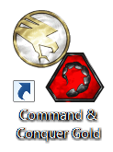After installing Command and Conquer, the player will see the icon for the game on the desktop. After double clicking the icon, the desktop work space goes away, and either the entire screen or a window opens the portal to the magic circle.

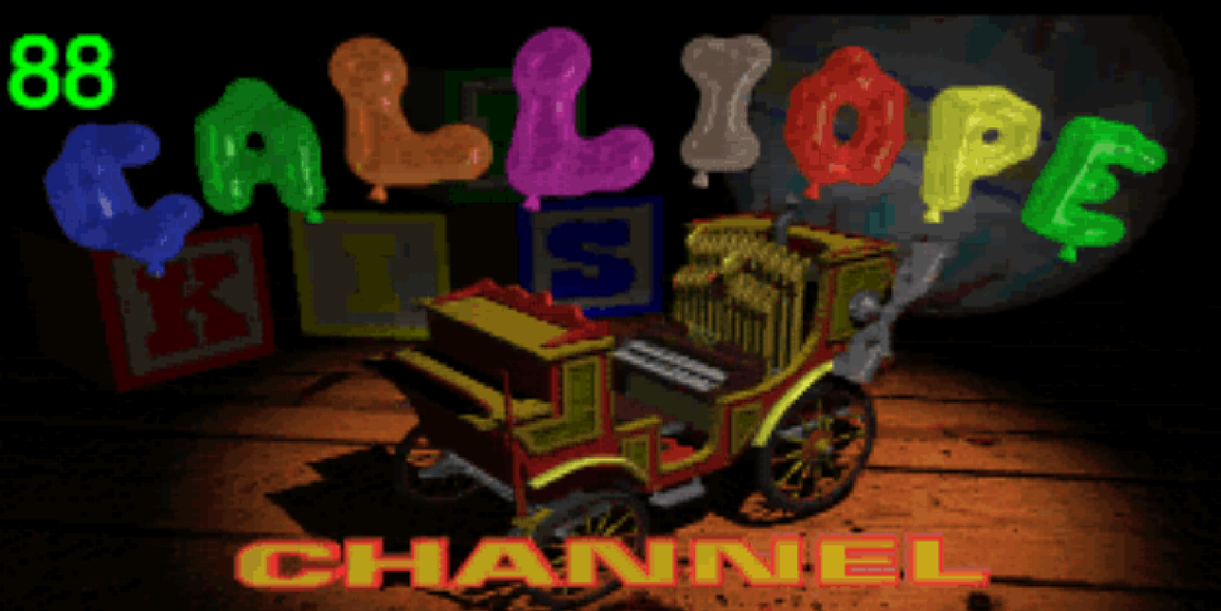

The first time entering this portal, the player is shown news stories, comical commercials, soap operas, etc. Without actually controlling anything, the player is channel surfing through analog tramissions. The analog portion is important because as some channels are fading in and out the player sees a giant symbol of an eagle or a scorpion relating to the channel’s content. Some transmissions even give direct information about the NOD Terroist group and Global Defense Initiative. Transmission fades, and then the player is finally ready to interact.

## The First Choice

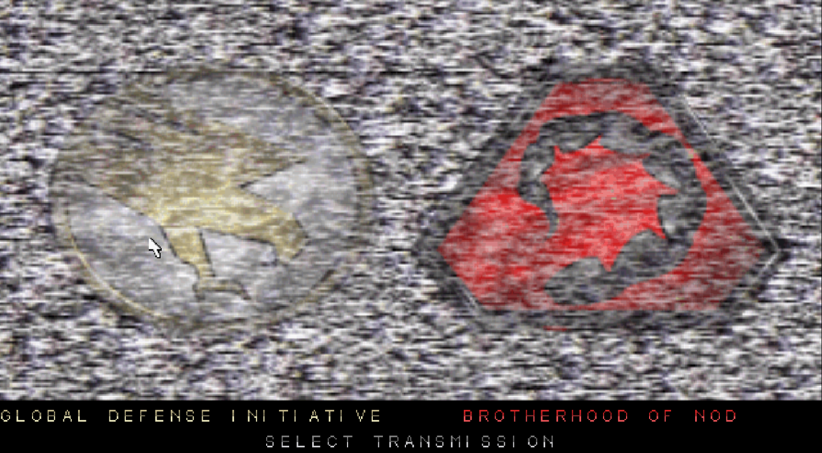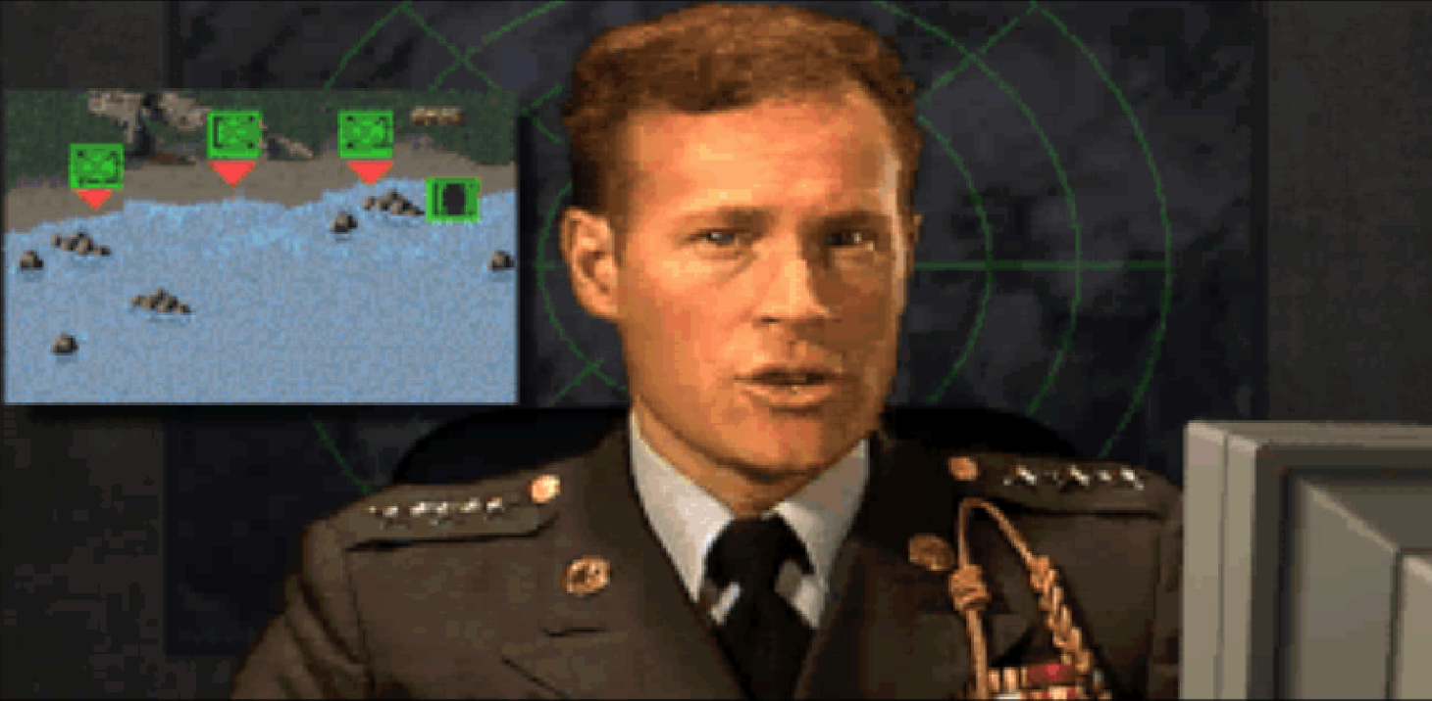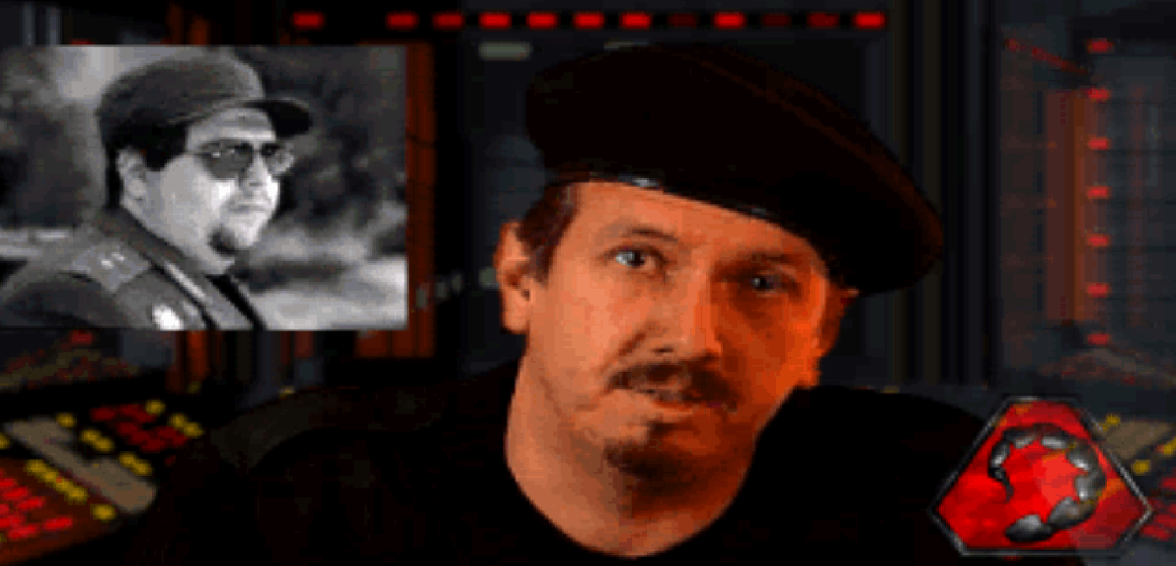

Once the transmission ends, the player is prompted to choose between Global Defense Initiative or the Brotherhood of NOD with two giant flashing symbols. At this point, the player should get the feeling that he/she is choosing between the “Good Guys” or “Bad Guys”.

If player chooses GDI, the player will see General Mark Sheppard. He gives the operational rules of the upcoming scene. “Your Mission is Simple. Knock out all fortififcations. Eliminate all NOD troops. Establish a beach head by building your base.” Visuals are shown on the screen as the mission is given. This shows a preview how units will be coming into play and what will be expected of them.

If player chooses NOD, the player will see “Seth”, Kane’s right hand man. (Kane being the leader of the brotherhood). His operational rules seems simpler but harder to follow. “This is Nikoomba. He is causing the Brotherhood much grief. His views do not coincide with ours, and that makes him dangerous. Silence him.” Equipped with only a picture of the man (which will not help the player at all), the player is left to figure out what to do with his army.

## Finally, The Game!

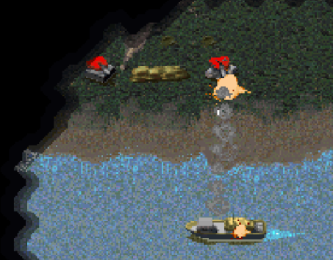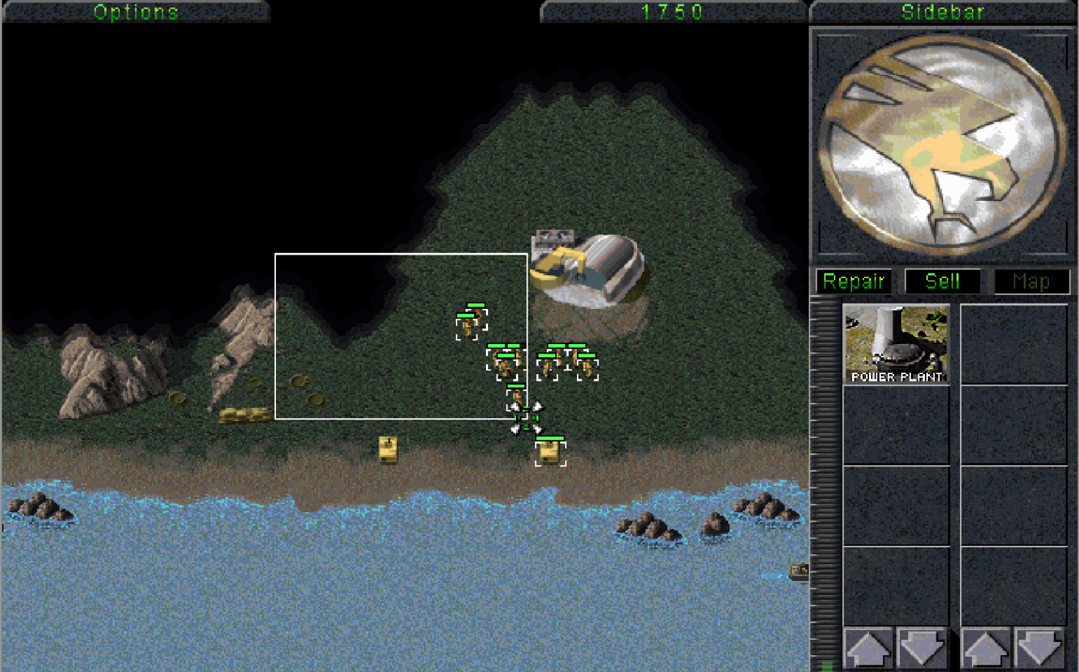

Battlefields, ships, soldiers, turrets. War! These are the semiotics Westwood has employed to get the player involved and understand the game. If the player selected GDI, the player is thrown in the middle of it. The first sound and sights are a yellow ship shooting rockets at red turrets on the shore. Little yellow soldiers approach the shore as mentioned in the briefing. There are little blue soldiers approaching yellow soldiers, both shoot, but the yellow army has the greater numbers and kill the blue soldiers. Half of the screen is also covered by a black shroud.

The “camera” of the game is a head-on ¾ view (not isometric). The player is not any one soldier or unit. There is a clear separation between the soldiers and the player (commander). If the player is looking for the experience of what it may feel like to be in a war, this is probably not the game for him/her. This game is more like a chess game where all players make moves simultaneously and positioning and timing are extremely important. This kind of play is best described as Real-time Strategy (RTS for short).

At this point the player starts learning the controls by trying different things. Westwood uses the same symbols that many operating systems like Windows or MacOS uses. A pointer that can move anywhere within the screen, boxes can be dragged out, and objects can be selected.

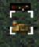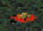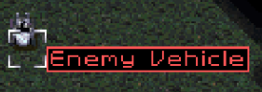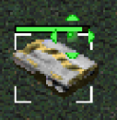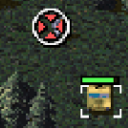

As the player selects units, the cursor changes to different shapes. Some deploy units, some attack other units. Colors are also helpful to differentiate which units belong to the player, and who belongs to the opponent. Tooltips are colored and shown to identify units, buildings, etc. Health bars are displayed over each selected unit. In just a couple of minutes, the player starts to understand how to manipulate the army on screen.

Most clicks have a discernable outcome. If a click was on the unit, a selection box appears over the unit, health bar appears, and a voice over the speakers say “Ready and waiting” or some other acknowledgement phrase. If a unit was selected and the ground was clicked, or there was a click in the vast black expanse, the selected unit immediately heads towards the cursor with a random confirmation sound, such as “Affirmative”.

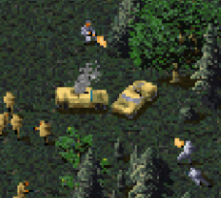

Learning the interface is just a part of the player’s experience. Hundreds of choices are available to the player from the start. Does the player move a single unit left? Right? Move two units? Move the jeep or the soldier? Move the whole army? Deploy a base? These choices are not listed, but as the player learns the interface, these tactics become more and more apparent. As the player plays more levels, a strategy begins to develop. Having more soldiers attacking a single soldier will increase the chance of killing the opponent soldier without losing any player soldiers. When and where a base deploys could be the difference between winning and losing.

Armies killing other armies is one aspect of this game. However, before armies can engage, they must be found. Sometimes the enemy finds the player, but most times, the player must decide to explore with his/her army. When a unit approaches the black shroud, the black shroud vanishes around the unit based on the unit’s range of sight, hence revealing more of the map. Does the player move one soldier to go explore at the risk of the soldier being killed if spotted? Or does the player send a jeep to explore and run when spotted? Or does the player go “balls to the wall” and send big armies in the vast expanse hoping to decimate anybody or anything that gets in the armies way?

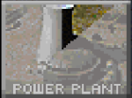

The other aspect of the game is base building. The player starts with a Mobile Construction Vehicle (MCV) which is a vehicle that deploys into a building that builds other buildings (makes sense, right?). This is the heart of any base, and once deployed, a new interface shows up on the right hand of the screen. A power bar, a list of buildings available to be built, and a list of units that can be built. There is also a number at the top of the screen that represent credits. Credits are spent to buy buildings, units, etc. Credits can be obtained via refining Tiberium. Tiberium is a substance that is desired by the entire world in the storyline. Everything takes time to produce, whether it’s a $3000 advanced building or a $100 minigunner. When to build is just as important as what to build.

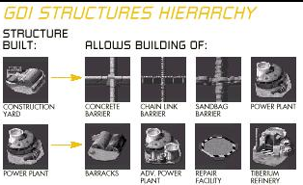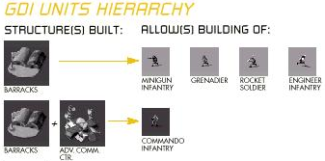As the player proceeds through all the levels, more and more building options will be available. There is a tech tree which determines which buildings open up additional building or units. Most of the time, the cut scene that precedes the start of the mission will give the player clues about which strategy will work best in the current mission. However, the basics strategy for all missions are to have enough power to run your base efficiently, have a source of income by building a refinery, and build bigger armies using a combination of buildings.

## Completing a Mission

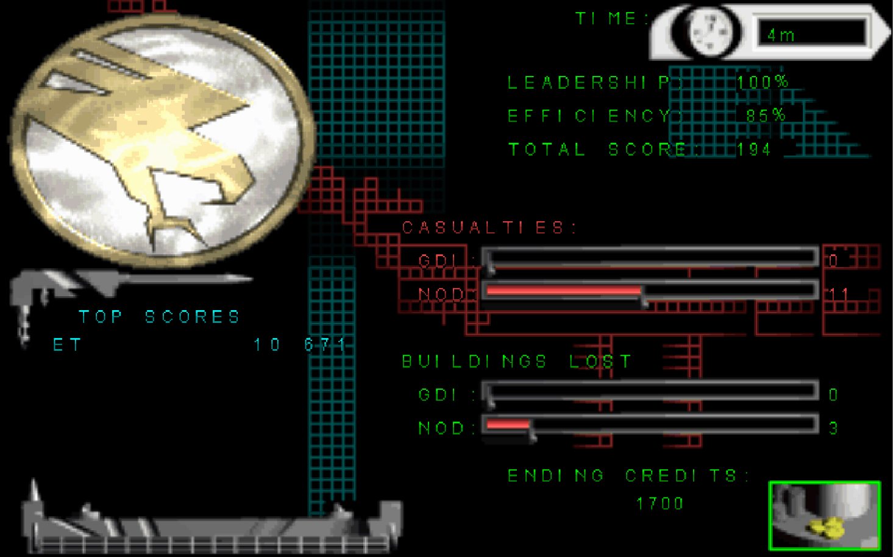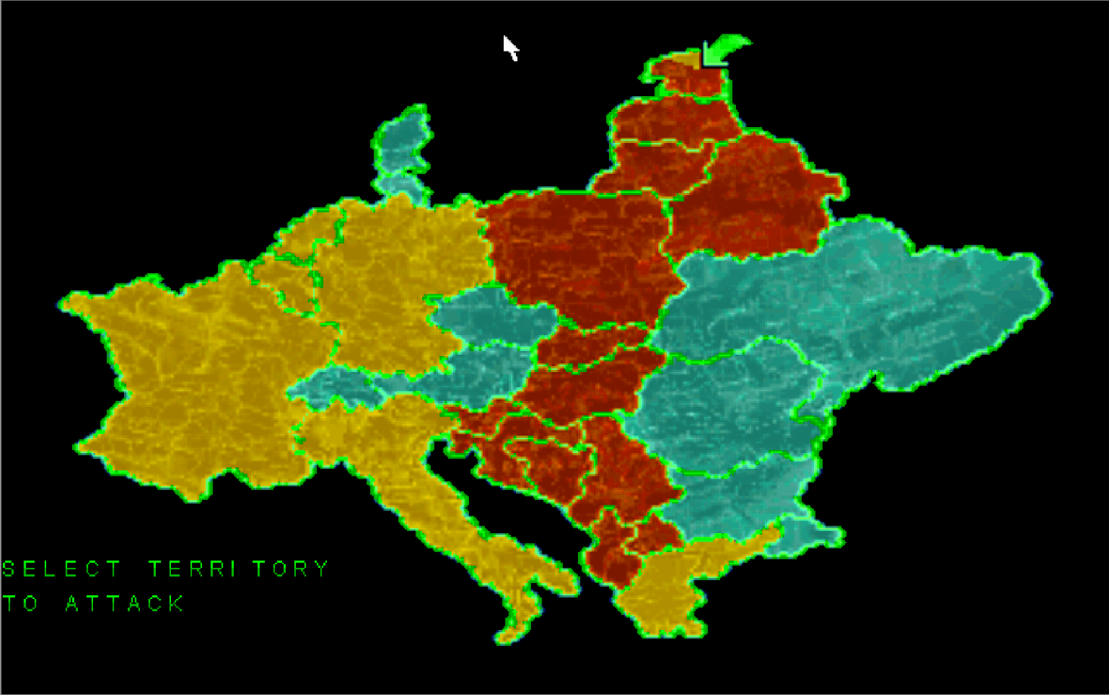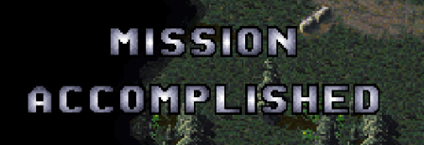

Most missions will be to destroy all enemy units and buildings. Upon completion of the mission, the player will see MISSION ACCOMPLISHED on the screen, perhaps a nice cut scene of what happened during or after the battle, and then a score screen. Number of units and buildings destroyed on both sides, number of earned credits, etc are all factors that probably led to the victory. (Please do not ask about Leadership or Effectiveness scores, as it almost seems like these values are not correlated to anything important in the missions). Then a map of either Europe or Africa appears. The goal of this is to make sure the entire map eventually turns into the player’s color (GDI gold or NOD red). There is no control over this, but depending on what country the player selects will determine the next mission.

## Balance and Multiplayer

Overall, the player controls one color of army, and other players/AI systems control the other armies of different colors. Different units have different strengths and weaknesses against other units. Numbers don’t always win the battle. A couple of flamethrowers can burn up entire armies of minigunners. Each faction (GDI or NOD) have different units available. Although there are different units, Westwood has done a good job balancing types of units where there is always a counter unit to any unit.

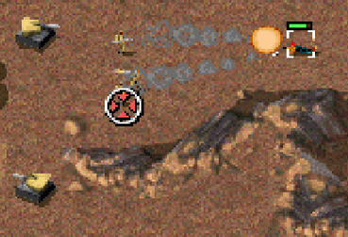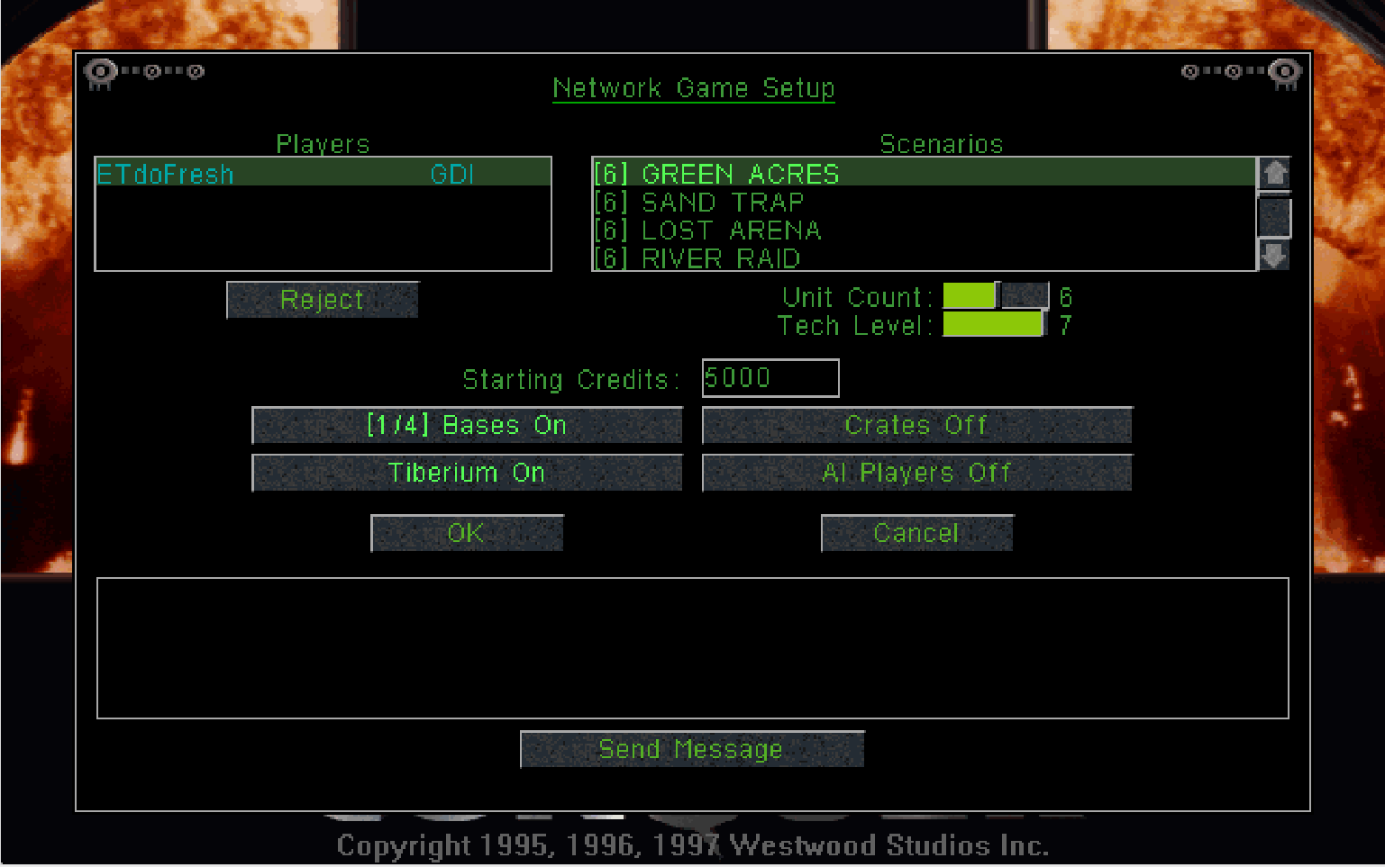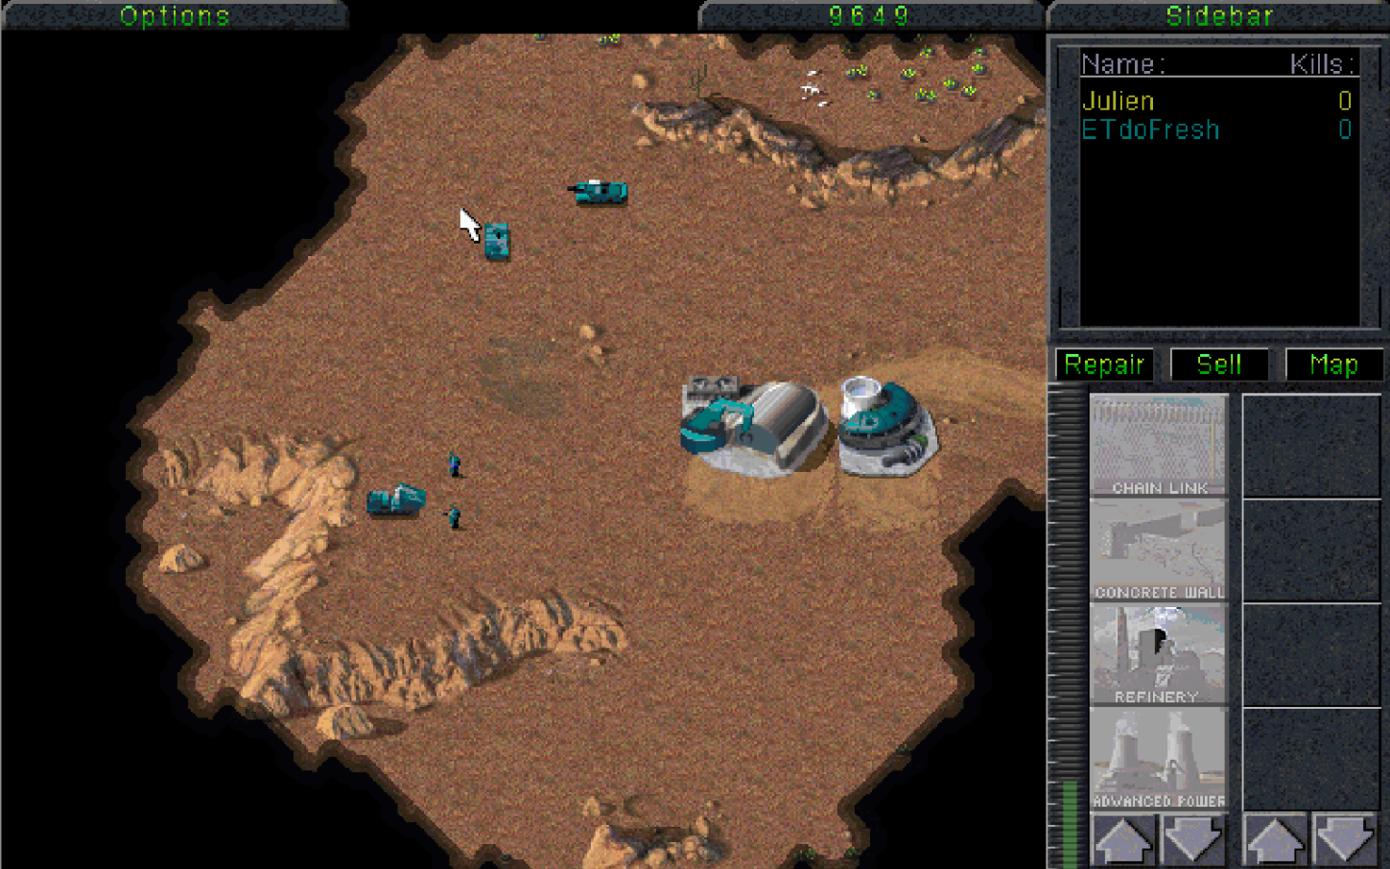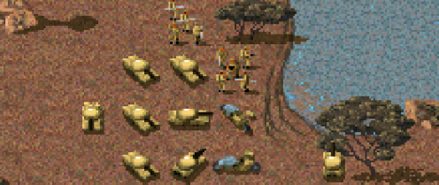

When playing other players, all buildings are available for each faction. In the pictures above, the player has one commando, and the other player has an army of bazooka men and tanks which is very weak against the commando. Although, the commando cannot destroy anything with armor like the tank, all the infantry is going to fall before the commando dies. An unfair trade in terms of credits (Commando - $1000, 15 assorted infantry - $4000). A clever mix of tactics and strategy determines the winner of each match.

Players can talk to each other via chat messages. The human-to-human interaction opens up the game beyond the closed system. Strategizing among allies to defeat enemies, celebrating victories, mourning defeats, and good ol’ trash talking are all aspects that take place inside of the game, and may have an external effect on the player. Memorable games will spark conversations far after the match has ended.